* Deloitte has dedicated professionals in independent firms throughout the world collaborate to provide the below services to the client
* Audit
* Financial Advisory (FA)
* Risk Advisory(RA)
* TAX
* IT Consulting
* All these firms are members of “Deloitte Touché Tohmatsu limited” a UK company
* Typically, a DTTL member firm may be a single or multiple country.
* These firms may or may not provide all the services depends on the laws and professional regulations of the particular country.

**Shared Services or Enabling areas:**

* Shared services develop a software needed by all the above functions or services.
* Shared services are divided into below teams
  + Product
  + CTO
  + PMO
  + Deployment team

**Product:**

* There are different channels are available in product and currently we are working for “Knowledge management channel”
* Under “Knowledge management channel” 5 Studios are available
* “Deloitte online” (DOL) is the one among the five.
* Other 4 channels are
  + Third party tools
  + Provisions of site collection
  + Microsoft team
    - Develop office 365
    - Maintenance of office 365
  + Maintenance of core delight online

**Deloitte online share point:**

* A SharePoint is a collaboration tool
* By using this SharePoint, we can interact or exchange data between external clients or internal clients or within the internal team
* We can even setup meetings
* SharePoint is a product from “Microsoft” and we used upgrade SharePoint according to the needs of the function
* Testing can be performed on new enhancement done on the new change request rather than entire SharePoint.
* SP DOL contains at least one firms (one or many)
* These firms again divided into below categories
  + Global Instance (US)
  + Local Instances – Few countries may need SharePoint specific to their own geographic region (Ex: France, China, Spain, Russia and Canada)
  + EU Instances-European region countries may need their own specific SharePoint (Germany, France, Switzerland, Belgium etc.)
  + DOLi (Deloitte online internal) -To share anything within internal team
* Internal Instance: Any person associated with the Deloitte and contains the Deloitte id (Full time or Part time or Vendor or any other)
* External Instance: Any person who doesn’t contains the Deloitte id.(External clients).
* A simple flow:

**SharePoint ---🡪 Firms --🡪Web Applications**

* Each firm contains 5 web applications (Audit, Financial Advisory, Risk Advisory, IT Consulting and Other)
* Tax is not involved here, and they opted for some other tool as they needed higher security.

**Site Collections:**

* Typically, a site collection is a web page and everything can be performed on site collection (Sharing the documents from clients or within team and calendar related things e.t.c)
* Depending on the access level provided in the site collection it can be either External or internal site collection

**External Site Collection**:

* After giving access to the site collection to the externally clients may share documents, or he may provide access to some other members.

**Internal Site Collection:**

* In this Internal Site collection, there is no option to provide access to the external users. (Only within the team)

**Nintex:**

* It is a 3nd party tool where we are using to create forms and to assign workflows to the items created to the list. (**List creation: Settings icon--🡪Site contents🡪Add an app-🡪Custom List)**
* Only SCA’s can perform these operations
* To perform this, we need “Site collection URL”

**Forms:**

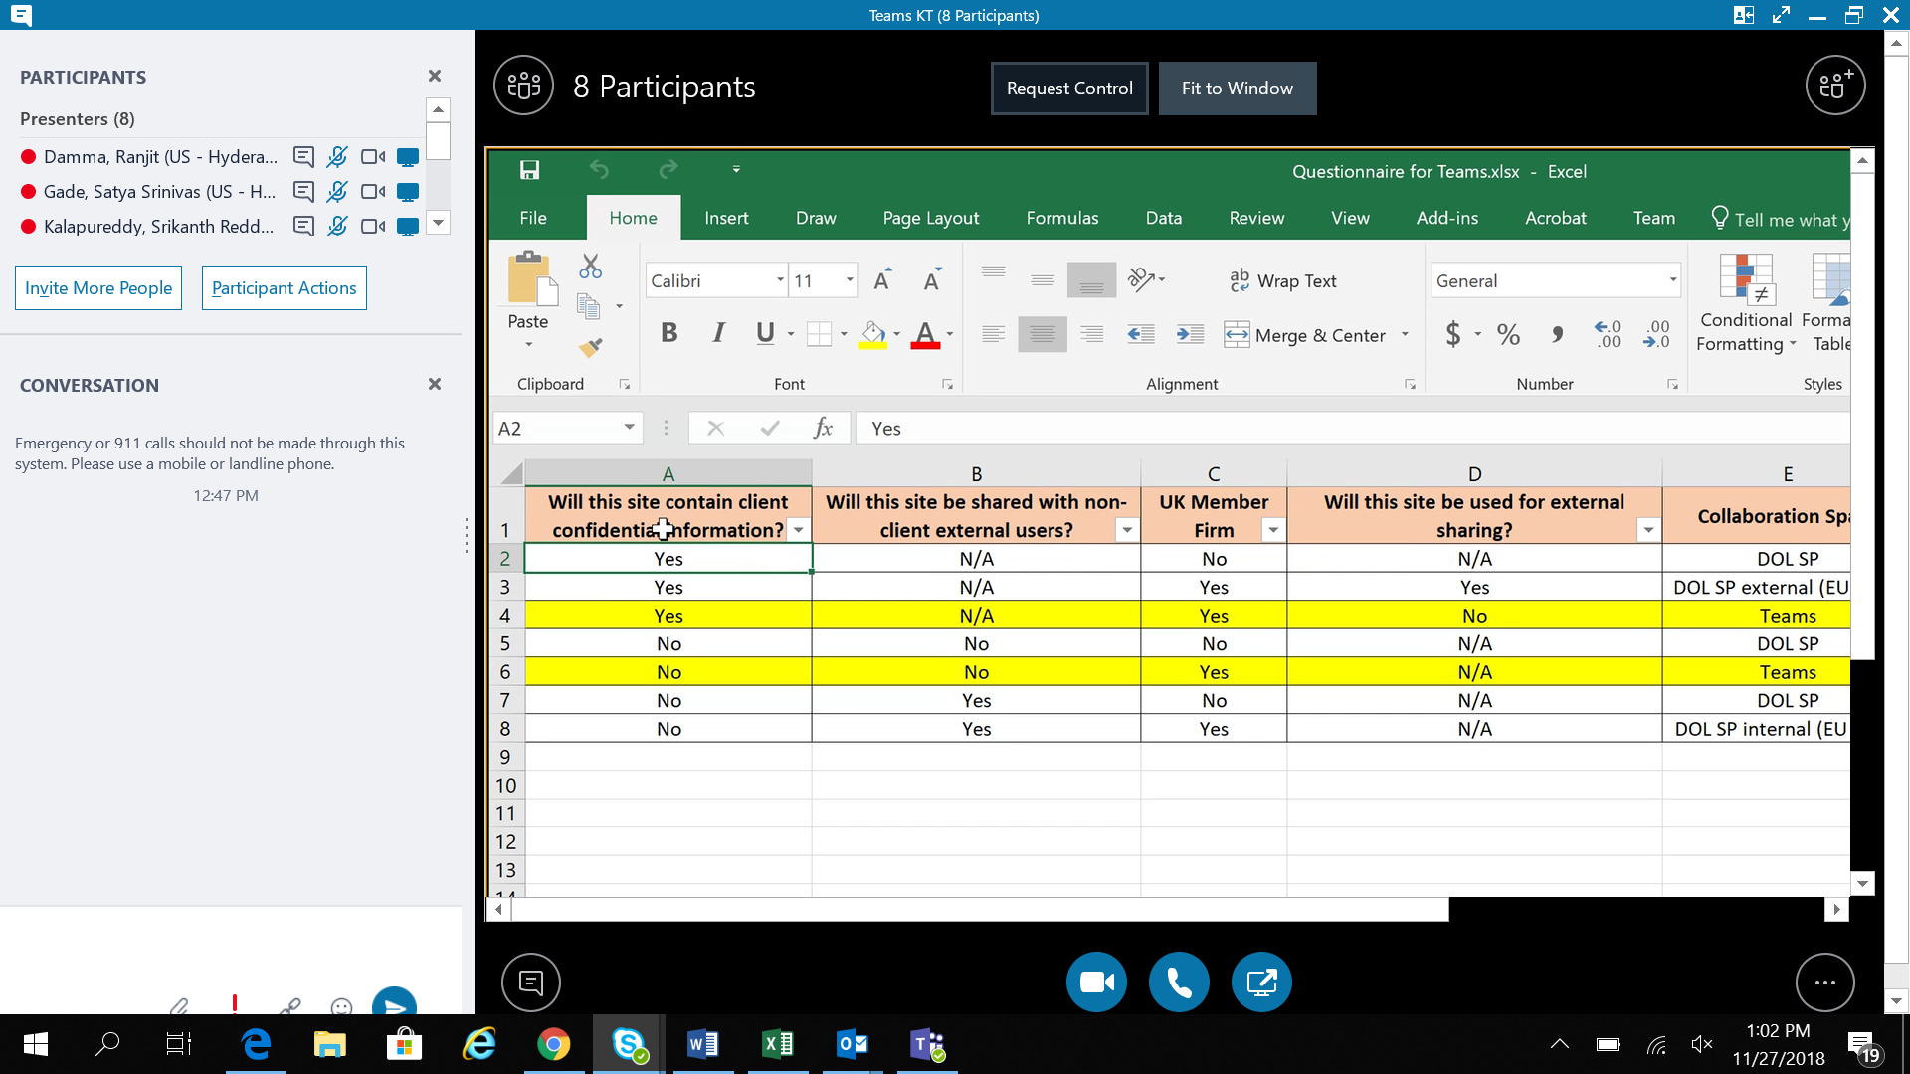

We can create 2 types of forms

1. Responsive Form
2. Classic Form

* By default, form contains “Title bar with buttons”
* You can customize the forms by navigating to “List🡪Nintex forms”.

Workflows:

Workflow defines process that follow to complete the necessary item.

* To access workflow navigate to “List-🡪Workflow settings-🡪Create a workflow in Nintext Workflow”
* Currently we are testing below workflows
  + - Send Notification
    - Assign Flexi task
    - Lazy task
    - Pause for

**9572-1Cr-80 … Critical illness …2800**

**Day-2**